Ideation Phase
Brainstorm & Idea Prioritization Template

Date | 25 February 2026
Team ID | LTVIP2026TMIDS81684
Project Name | Calculating Family Expenses using ServiceNow
Maximum Marks | 4 Marks

Brainstorm & Idea Prioritization Template:
Brainstorming provides a free own brainstorming sessions so your team can unleash their imagination and start shaping concepts even if you're not sitting in the same room.
Reference: https://www.mural.co/templates/brainstorm-and-idea-prioritization

Step-1: Team Gathering, Collaboration and Select the Problem Statement:
The team gathered to discuss common challenges faced in managing family expenses using traditional methods such as manual recording or scattered digital tools. After discussion, the team identified the need for a centralized system that can help families track expenses efficiently and improve financial planning.
Problem Statement:
Many families face difficulties in tracking and managing their daily expenses due to lack of centralized tools, manual record keeping, and absence of proper financial monitoring systems. This leads to poor financial visibility and inefficient budget management. Therefore, there is a need to develop a system that allows users to record, monitor, and analyze family expenses in an organized manner.

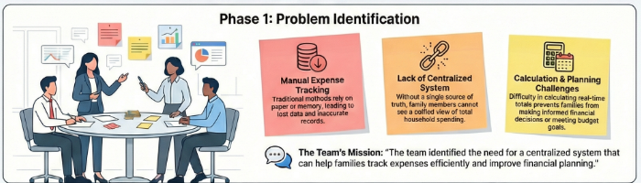
Step-2: Brainstorm, Idea Listing and Grouping:
During brainstorming, the team generated multiple ideas to solve the identified problem. Ideas included developing a digital platform for recording expenses, enabling multiple users to enter expense data, automating expense calculations, providing monthly reports, and integrating workflows using the ServiceNow platform.
The generated ideas were grouped into the following categories:
• Expense Tracking – Recording daily expenses and managing financial data
• Automation – Automatic calculations and workflow integration
• Reporting & Monitoring – Generating reports and analyzing spending patterns
• User Experience – Simple forms and easy navigation
• Data Management – Centralized storage and secure access

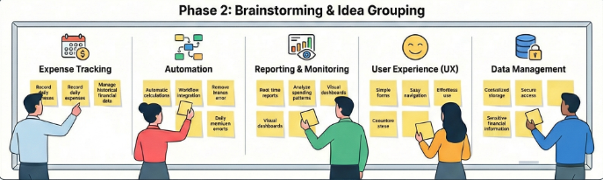
Step-3: Idea Prioritization:
After evaluating the feasibility and importance of the generated ideas, the team decided to prioritize the development of a centralized Family Expense Management System using the ServiceNow platform. This solution was selected because it provides automation, centralized data storage, scalability, and reporting capabilities while being feasible to implement within the project timeline and available resources.

